**3D-Elephant Head Wall Mount**

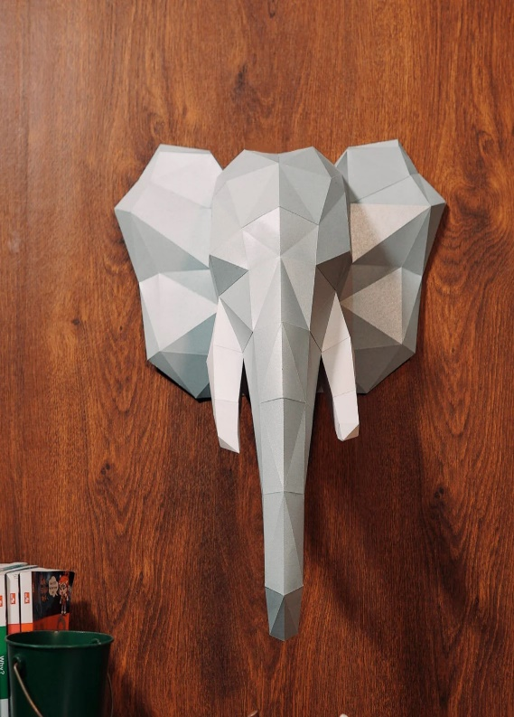The 3D Elephant Head Wall Mount is a majestic and awe-inspiring piece of art that adds a touch of grandeur and sophistication to any space. With its intricately designed tusks, textured skin, and lifelike features, this wall mount captures the essence of the elephant’s strength and grace. The three-dimensional construction brings depth and realism, making it an impressive focal point for living rooms, offices, or entryways. Its combination of artistic craftsmanship and natural beauty makes it a perfect fit for both modern and traditional interiors, while symbolizing wisdom, power, and good fortune. Whether in a contemporary home or a more rustic setting, this striking elephant head serves as a powerful statement piece that radiates both elegance and personality...